IFT 530: Advanced Database Management System

Team – 75

Sreeja Vaddi

Sai Krishna Samudrala

Final Project: Rental Car Management System

Due Date: 04th Dec 2024

**Creating the Tables**

**Tables we have used:**

1. **Customer_Details:**

SQL Script:

CREATE TABLE Customer_Details

(

FNAME VARCHAR(35) NOT NULL,

MNAME VARCHAR(20),

LNAME VARCHAR(35) NOT NULL,

EMAIL_ID VARCHAR(50) NOT NULL,

PHONE_NUMBER CHAR(12) NOT NULL,

STREET VARCHAR(50) NOT NULL,

CITY VARCHAR(30) NOT NULL,

STATE_NAME VARCHAR(30) NOT NULL,

ZIPCODE CHAR(6) NOT NULL,

MEMBERSHIP_ID CHAR(8),

MEMBERSHIP_TYPE CHAR(1) DEFAULT 'N' NOT NULL,

DL_NUMBER CHAR(10) NOT NULL,

CONSTRAINT CUSTOMERPK PRIMARY KEY (DL_NUMBER)

);

1. **Car_Category:**

SQL Script:

CREATE TABLE Car_Category

(

CATEGORY_NAME VARCHAR(30) NOT NULL,

COST_PER_DAY DECIMAL(7, 2) NOT NULL,

LATE_FEE_PER_HOUR DECIMAL(6, 2) NOT NULL,

NO_OF_PERSON INTEGER NOT NULL,

NO_OF_LUGGAGE INTEGER NOT NULL,

CONSTRAINT CARCATEGORYPK PRIMARY KEY (CATEGORY_NAME)

);

1. **Location_Details:**

SQL Script:

CREATE TABLE Location_Details

(

LOCATION_ID CHAR(6) NOT NULL,

LOCATION_NAME VARCHAR(60) NOT NULL,

CITY VARCHAR(30) NOT NULL,

STATE_NAME VARCHAR(30) NOT NULL,

STREET VARCHAR(40) NOT NULL,

ZIPCODE CHAR(6) NOT NULL,

CONSTRAINT LOCATIONPK PRIMARY KEY (LOCATION_ID)

);

1. **Car:**

SQL Script:

CREATE TABLE Car

(

REGISTRATION_NUMBER CHAR(10) NOT NULL,

MODEL_NAME VARCHAR(30) NOT NULL,

MAKE VARCHAR(30) NOT NULL,

CAR_CATEGORY_NAME VARCHAR(30) NOT NULL,

LOC_ID CHAR(6) NOT NULL,

MODEL_YEAR DECIMAL(4) NOT NULL,

MILEAGE INTEGER NOT NULL,

AVAILABILITY_FLAG CHAR(1) NOT NULL,

CONSTRAINT CARPK PRIMARY KEY (REGISTRATION_NUMBER),

CONSTRAINT CARFK1 FOREIGN KEY (CAR_CATEGORY_NAME) REFERENCES Car_Category(CATEGORY_NAME),

CONSTRAINT CARFK2 FOREIGN KEY (LOC_ID) REFERENCES Location_Details(LOCATION_ID)

);

1. **Discount_Details:**

SQL Script:

CREATE TABLE Discount_Details

(

DISCOUNT_CODE CHAR(6) NOT NULL,

DISCOUNT_NAME VARCHAR(30) NOT NULL,

DISCOUNT_PERCENTAGE DECIMAL(5, 2) NOT NULL,

EXPIRY_DATE DATE NOT NULL,

CONSTRAINT DISCOUNTPK PRIMARY KEY (DISCOUNT_CODE),

CONSTRAINT DISCOUNTSK UNIQUE (DISCOUNT_NAME)

);

1. **Rental_car_Insurance:**

SQL Script:

CREATE TABLE Rental_Car_Insurance

(

INSURANCE_CODE CHAR(6) NOT NULL,

INSURANCE_NAME VARCHAR(60) NOT NULL,

COST_PER_DAY DECIMAL(6, 2) NOT NULL,

COVERAGE_TYPE VARCHAR(250) NOT NULL,

CONSTRAINT INSURANCEPK PRIMARY KEY (INSURANCE_CODE),

CONSTRAINT INSURANCESK UNIQUE (INSURANCE_NAME)

);

1. **Booking_Details:**

SQL Script:

CREATE TABLE Booking_Details

(

BOOKING_ID CHAR(5) NOT NULL,

REG_NUM CHAR(10) NOT NULL,

DL_NUM CHAR(10) NOT NULL,

AMOUNT DECIMAL(12, 2) NOT NULL,

BOOKING_STATUS CHAR(1) NOT NULL,

PICKUP_LOC CHAR(6) NOT NULL,

DROP_LOC CHAR(6) NOT NULL,

INS_CODE CHAR(6),

DISCOUNT_CODE CHAR(6),

CONSTRAINT BOOKINGPK PRIMARY KEY (BOOKING_ID),

CONSTRAINT BOOKINGFK1 FOREIGN KEY (PICKUP_LOC) REFERENCES Location_Details(LOCATION_ID),

CONSTRAINT BOOKINGFK2 FOREIGN KEY (DROP_LOC) REFERENCES Location_Details(LOCATION_ID),

CONSTRAINT BOOKINGFK3 FOREIGN KEY (REG_NUM) REFERENCES Car(REGISTRATION_NUMBER),

CONSTRAINT BOOKINGFK4 FOREIGN KEY (DL_NUM) REFERENCES Customer_Details(DL_NUMBER),

CONSTRAINT BOOKINGFK5 FOREIGN KEY (INS_CODE) REFERENCES Rental_Car_Insurance(INSURANCE_CODE),

CONSTRAINT BOOKINGFK6 FOREIGN KEY (DISCOUNT_CODE) REFERENCES Discount_Details(DISCOUNT_CODE)

);

1. **Billing_Details:**

SQL Script:

CREATE TABLE Billing_Details (

BILL_ID CHAR(6) NOT NULL,

BILL_DATE DATE NOT NULL,

BILL_STATUS CHAR(1) NOT NULL,

DISCOUNT_AMOUNT DECIMAL(10, 2) NOT NULL,

TOTAL_AMOUNT DECIMAL(10, 2) NOT NULL,

TAX_AMOUNT DECIMAL(10, 2) NOT NULL,

BOOKING_ID CHAR(5) NOT NULL,

TOTAL_LATE_FEE DECIMAL(10, 2) NOT NULL,

CONSTRAINT BILLINGPK PRIMARY KEY (BILL_ID),

CONSTRAINT BILLINGFK1 FOREIGN KEY (BOOKING_ID) REFERENCES BOOKING_DETAILS(BOOKING_ID)

);

**Command to Show the tables created:**

**Script:**

select * from sys.tables

**Output:**

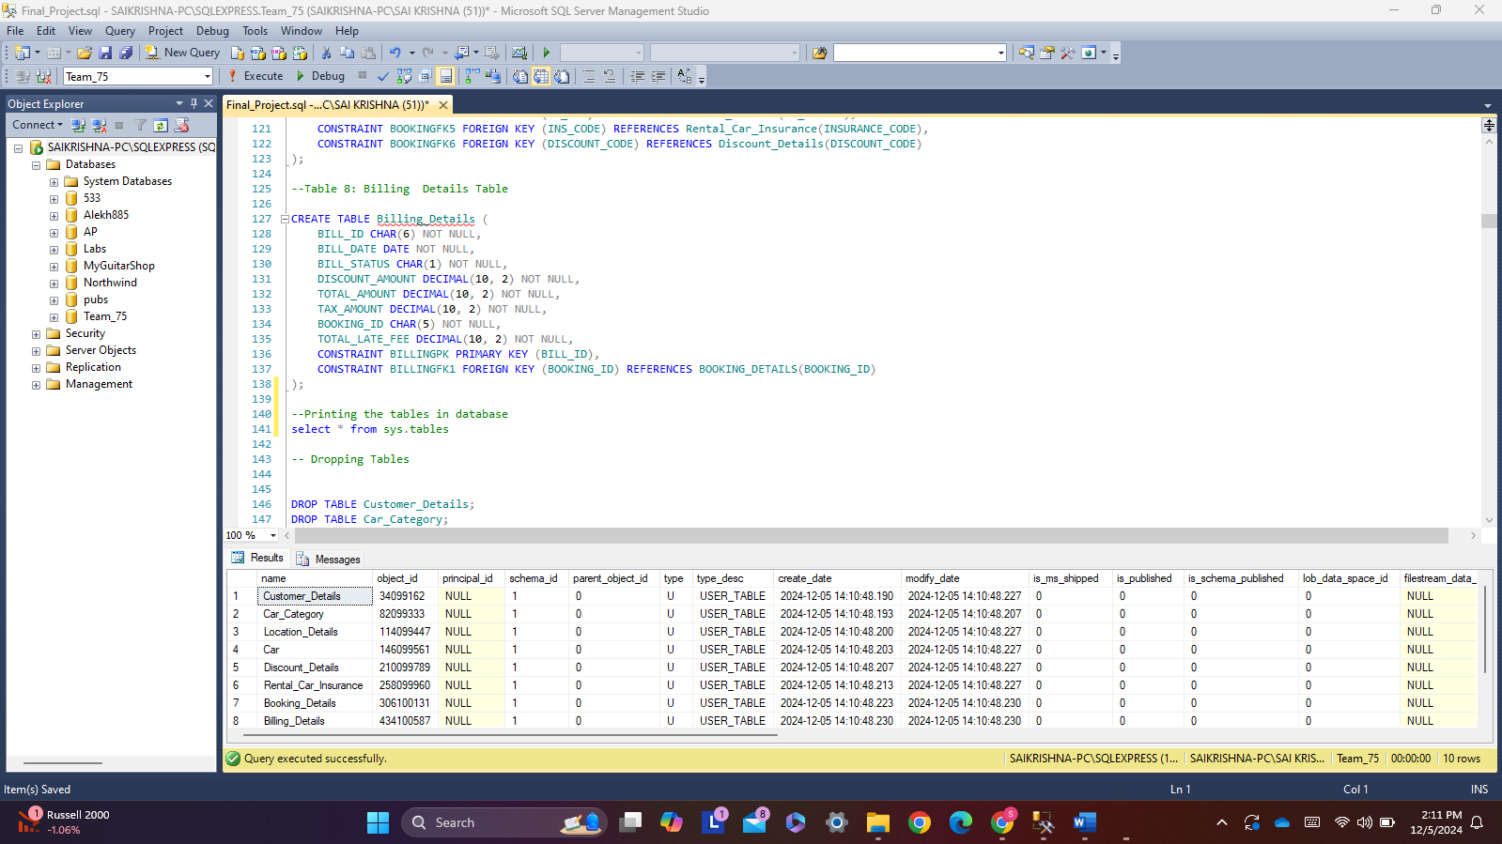

**Command to Drop the tables:**

DROP TABLE Customer_Details;

DROP TABLE Car_Category;

DROP TABLE Location_Details;

DROP TABLE Car;

DROP TABLE Discount_Details;

DROP TABLE Rental_Car_Insurance;

DROP TABLE Booking_Details;

DROP TABLE Billing_Details;

**Entity Relationship Diagram**

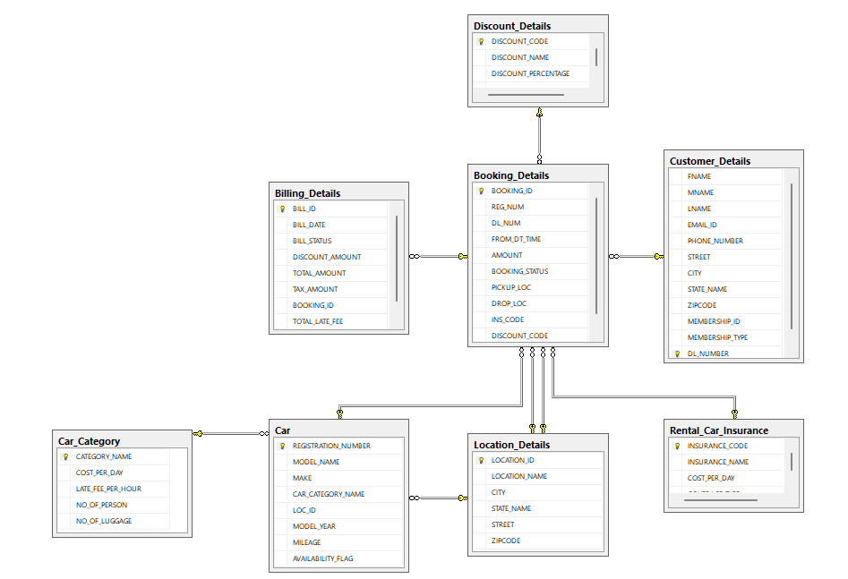

**Populating the Tables**

Script for Customer Table:

INSERT INTO Customer_Details

(

FNAME, MNAME, LNAME, EMAIL_ID, PHONE_NUMBER, STREET, CITY, STATE_NAME, ZIPCODE, MEMBERSHIP_ID, MEMBERSHIP_TYPE, DL_NUMBER

)

VALUES

('John', 'A.', 'Doe', 'john.doe@example.com', '123-456-7890', '123 Elm St', 'Springfield', 'Illinois', '62701', 'MEM12345', 'Y', 'D123456789'),

('Jane', 'B.', 'Smith', 'jane.smith@example.com', '987-654-3210', '456 Oak St', 'Riverside', 'California', '92501', 'MEM54321', 'N', 'S987654321'),

('Michael', 'C.', 'Johnson', 'michael.johnson@example.com', '555-123-4567', '789 Pine St', 'Hometown', 'Texas', '75001', 'MEM67890', 'Y', 'M123456789'),

('Emily', 'D.', 'Williams', 'emily.williams@example.com', '444-321-9876', '101 Maple Ave', 'Weston', 'Florida', '33301', 'MEM09876', 'N', 'W987654321'),

('Daniel', 'E.', 'Brown', 'daniel.brown@example.com', '666-543-2109', '202 Birch Rd', 'Chattanooga', 'Tennessee', '37401', 'MEM24680', 'Y', 'B123456789'),

('Sophia', 'F.', 'Jones', 'sophia.jones@example.com', '333-765-4321', '303 Cedar Ln', 'Madison', 'Wisconsin', '53703', 'MEM13579', 'N', 'J987654321'),

('Lucas', 'G.', 'Miller', 'lucas.miller@example.com', '777-234-5678', '404 Pine Rd', 'Boulder', 'Colorado', '80301', 'MEM36912', 'Y', 'L123456789'),

('Olivia', 'H.', 'Davis', 'olivia.davis@example.com', '888-432-1098', '505 Cedar Dr', 'Seattle', 'Washington', '98101', 'MEM75386', 'N', 'D987654321'),

('Ethan', 'I.', 'Martinez', 'ethan.martinez@example.com', '222-654-1230', '606 Oak Blvd', 'Portland', 'Oregon', '97201', 'MEM48123', 'Y', 'M123987654'),

('Ava', 'J.', 'Garcia', 'ava.garcia@example.com', '111-987-6543', '707 Elm Blvd', 'Miami', 'Florida', '33101', 'MEM97531', 'N', 'G987123456');

SELECT*FROM Customer_Details;

Output:

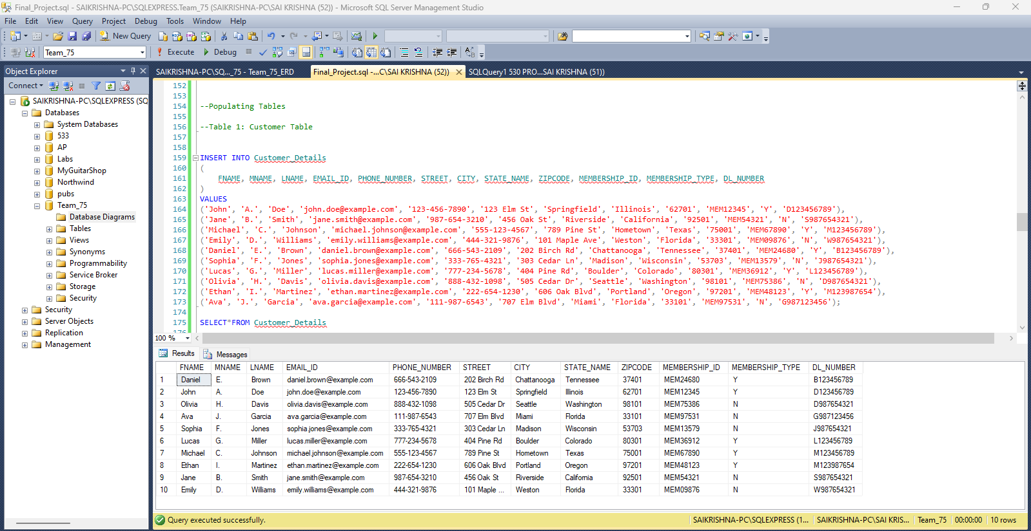

Script for Car Category Table:

INSERT INTO Car_Category

(CATEGORY_NAME, COST_PER_DAY, LATE_FEE_PER_HOUR, NO_OF_PERSON, NO_OF_LUGGAGE)

VALUES

('Electric', 100.00, 20.00, 4, 2),

('Sedan', 60.00, 15.00, 4, 3),

('SUV', 80.00, 18.00, 5, 4),

('Compact', 50.00, 12.00, 4, 2),

('Hybrid', 75.00, 16.00, 4, 3),

('Truck', 120.00, 25.00, 2, 5),

('Minivan', 90.00, 20.00, 7, 3),

('Sports', 150.00, 30.00, 2, 3),

('Luxury', 200.00, 35.00, 4, 2),

('Convertible', 180.00, 28.00, 2, 2),

('Coupe', 70.00, 14.00, 4, 3),

('Crossover', 85.00, 17.00, 5, 4),

('Wagon', 95.00, 19.00, 5, 4),

('Hatchback', 65.00, 13.00, 4, 2),

('Midsize', 72.00, 16.00, 4, 3),

('Fullsize', 85.00, 18.00, 5, 4),

('Roadster', 130.00, 27.00, 2, 2),

('Luxury SUV', 150.00, 30.00, 5, 5),

('Executive', 160.00, 32.00, 4, 2),

('Off-road', 140.00, 29.00, 4, 5),

('Pickup', 110.00, 22.00, 2, 6),

('Minivan XL', 115.00, 23.00, 8, 4),

('Economy', 55.00, 11.00, 4, 2),

('Cargo Van', 120.00, 25.00, 2, 8),

('Subcompact', 48.00, 10.00, 4, 2),

('MPV', 95.00, 19.00, 7, 4),

('Pickup Extended', 125.00, 24.00, 3, 5),

('Sport Coupe', 135.00, 26.00, 2, 3),

('Grand Tourer', 170.00, 34.00, 4, 3),

('Utility Vehicle', 90.00, 20.00, 5, 5),

('City Car', 45.00, 9.00, 4, 1),

('Compact SUV', 78.00, 17.00, 5, 3),

('Luxury Sedan', 210.00, 40.00, 4, 3),

('Four-door Sedan', 65.00, 14.00, 5, 3),

('Coupe SUV', 95.00, 19.00, 4, 3),

('Convertible SUV', 170.00, 35.00, 4, 2),

('Touring Sedan', 120.00, 25.00, 4, 3),

('Family Van', 85.00, 18.00, 6, 4),

('Executive Sedan', 190.00, 38.00, 4, 3),

('Newmodel Car', 100.00, 35.00, 1, 2);

SELECT*FROM Car_Category;

Output:

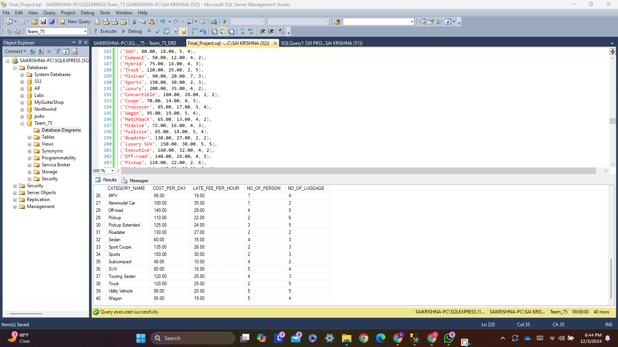

Script for Location Table:

INSERT INTO Location_Details

(LOCATION_ID, LOCATION_NAME, CITY, STATE_NAME, STREET, ZIPCODE)

VALUES

('LOC001', 'Downtown Center', 'New York', 'NY', '123 Main St', '10001'),

('LOC002', 'Uptown Plaza', 'New York', 'NY', '456 Oak Ave', '10002'),

('LOC003', 'City Square', 'Los Angeles', 'CA', '789 Pine Rd', '90001'),

('LOC004', 'Beachside Park', 'Los Angeles', 'CA', '101 Beach Dr', '90002'),

('LOC005', 'Park View', 'Chicago', 'IL', '234 Elm St', '60001'),

('LOC006', 'Greenwood Station', 'Chicago', 'IL', '567 Maple Ave', '60002'),

('LOC007', 'Mountain Ridge', 'Denver', 'CO', '890 Mountain Rd', '80201'),

('LOC008', 'City Gateway', 'Denver', 'CO', '321 Canyon St', '80202'),

('LOC009', 'Lakefront Park', 'San Francisco', 'CA', '678 Lakeshore Blvd', '94101'),

('LOC010', 'Sunset View', 'San Francisco', 'CA', '135 Sunset Rd', '94102'),

('LOC011', 'Riverbend Plaza', 'Austin', 'TX', '246 River Rd', '73301'),

('LOC012', 'Highland Square', 'Austin', 'TX', '789 Highland Blvd', '73302'),

('LOC013', 'Northern Lights', 'Seattle', 'WA', '102 Pine St', '98101'),

('LOC014', 'Southgate Mall', 'Seattle', 'WA', '654 Birch Ave', '98102'),

('LOC015', 'Ocean Breeze', 'Miami', 'FL', '321 Ocean Dr', '33101'),

('LOC016', 'Bayfront Park', 'Miami', 'FL', '654 Bay Rd', '33102'),

('LOC017', 'Sunny Hills', 'Phoenix', 'AZ', '987 Desert Ave', '85001'),

('LOC018', 'Cactus Valley', 'Phoenix', 'AZ', '654 Cactus St', '85002'),

('LOC019', 'Golden Gate', 'San Diego', 'CA', '741 Gold St', '92101'),

('LOC020', 'Pacific Horizon', 'San Diego', 'CA', '852 Pacific Blvd', '92102'),

('LOC021', 'Mountain Pass', 'Salt Lake City', 'UT', '123 Snowy Rd', '84101'),

('LOC022', 'Lakeview Heights', 'Salt Lake City', 'UT', '234 Lake St', '84102'),

('LOC023', 'Vista Ridge', 'Dallas', 'TX', '345 Hillcrest Rd', '75201'),

('LOC024', 'Parkway View', 'Dallas', 'TX', '456 Park St', '75202'),

('LOC025', 'Riverstone Plaza', 'Houston', 'TX', '567 Riverstone Dr', '77001'),

('LOC026', 'Clearwater Shores', 'Houston', 'TX', '678 Clearwater Blvd', '77002'),

('LOC027', 'Lakeside Gardens', 'Boston', 'MA', '789 Lakeside Ave', '02101'),

('LOC028', 'Beacon Hill', 'Boston', 'MA', '890 Beacon St', '02102'),

('LOC029', 'Maple Grove', 'Minneapolis', 'MN', '123 Maple Ave', '55101'),

('LOC030', 'Stonebrook Park', 'Minneapolis', 'MN', '456 Stone Rd', '55102'),

('LOC031', 'Brighton Square', 'Detroit', 'MI', '567 Brighton Blvd', '48201'),

('LOC032', 'Windy Acres', 'Detroit', 'MI', '678 Windy St', '48202'),

('LOC033', 'Crystal Bay', 'Portland', 'OR', '789 Crystal Rd', '97201'),

('LOC034', 'Silver Ridge', 'Portland', 'OR', '890 Silver St', '97202'),

('LOC035', 'Silverlake Mall', 'Las Vegas', 'NV', '345 Silverlake Ave', '89101'),

('LOC036', 'Desert Oasis', 'Las Vegas', 'NV', '456 Desert Rd', '89102'),

('LOC037', 'Westside Plaza', 'Philadelphia', 'PA', '567 West Ave', '19101'),

('LOC038', 'Riverwalk Park', 'Philadelphia', 'PA', '678 Riverwalk St', '19102'),

('LOC039', 'Sunrise Heights', 'Orlando', 'FL', '123 Sunrise Rd', '32801'),

('LOC040', 'Palm Grove', 'Orlando', 'FL', '456 Palm Ave', '32802');

SELECT*FROM Location_Details;

Output:

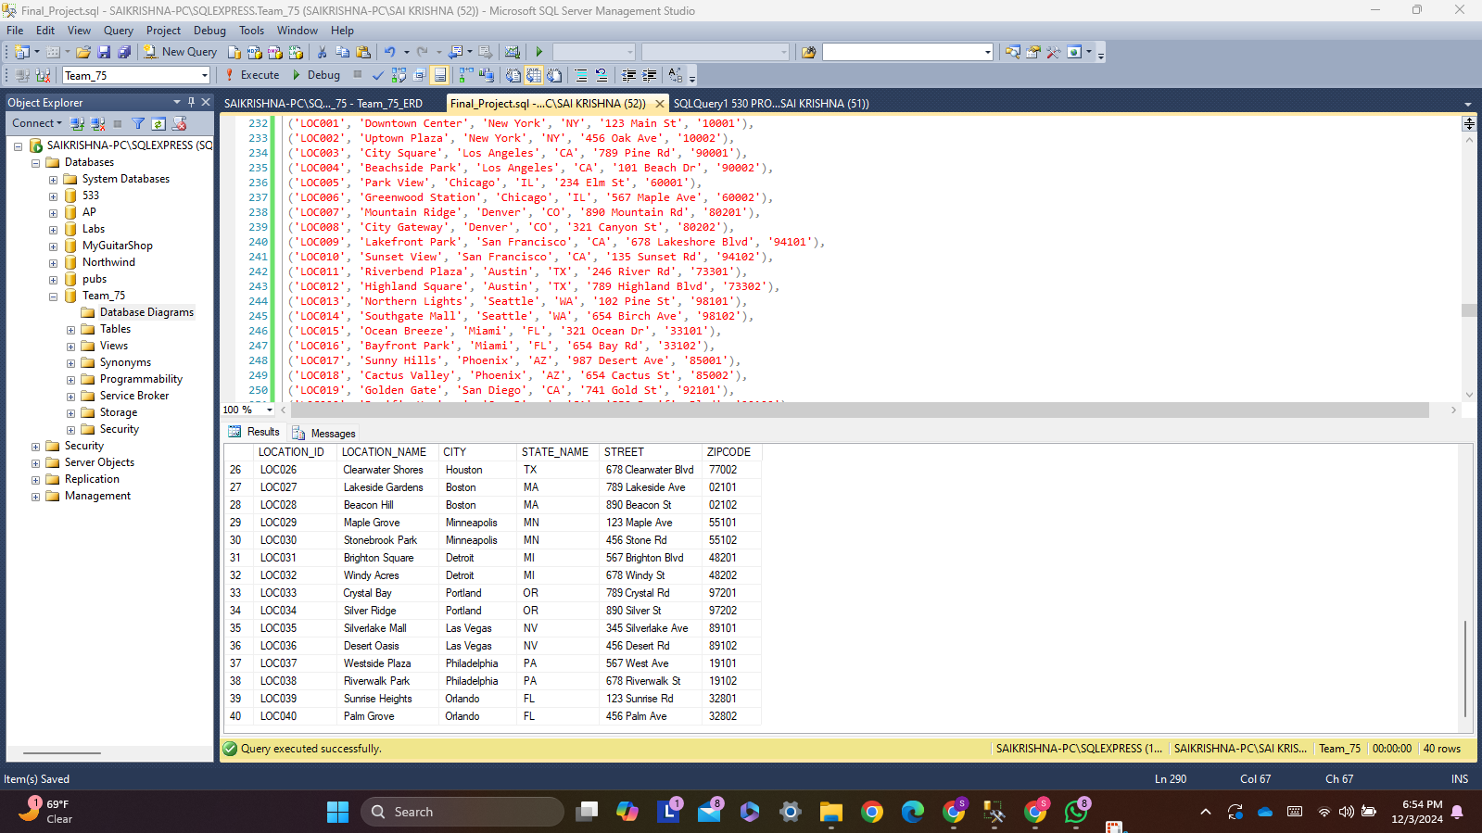

Script for Car Table:

INSERT INTO Car

(REGISTRATION_NUMBER, MODEL_NAME, MAKE, CAR_CATEGORY_NAME, LOC_ID, MODEL_YEAR, MILEAGE, AVAILABILITY_FLAG)

VALUES

('REG001', 'Model A', 'Toyota', 'Electric', 'LOC001', 2020, 15000, 'Y'),

('REG002', 'Model B', 'Honda', 'Sedan', 'LOC002', 2019, 20000, 'Y'),

('REG003', 'Model C', 'Ford', 'SUV', 'LOC003', 2021, 12000, 'Y'),

('REG004', 'Model D', 'Chevrolet', 'Compact', 'LOC004', 2020, 18000, 'Y'),

('REG005', 'Model E', 'Nissan', 'Hybrid', 'LOC005', 2022, 8000, 'Y'),

('REG006', 'Model F', 'Ram', 'Truck', 'LOC006', 2021, 25000, 'Y'),

('REG007', 'Model G', 'Chrysler', 'Minivan', 'LOC007', 2019, 22000, 'Y'),

('REG008', 'Model H', 'Porsche', 'Sports', 'LOC008', 2020, 9000, 'Y'),

('REG009', 'Model I', 'BMW', 'Luxury', 'LOC009', 2021, 5000, 'Y'),

('REG010', 'Model J', 'Mercedes', 'Convertible', 'LOC010', 2021, 7000, 'Y'),

('REG011', 'Model K', 'Mazda', 'Coupe', 'LOC011', 2020, 15000, 'Y'),

('REG012', 'Model L', 'Jeep', 'Crossover', 'LOC012', 2022, 6000, 'Y'),

('REG013', 'Model M', 'Subaru', 'Wagon', 'LOC013', 2021, 13000, 'Y'),

('REG014', 'Model N', 'Hyundai', 'Hatchback', 'LOC014', 2020, 14000, 'Y'),

('REG015', 'Model O', 'Kia', 'Midsize', 'LOC015', 2022, 7000, 'Y'),

('REG016', 'Model P', 'Toyota', 'Fullsize', 'LOC016', 2019, 19000, 'Y'),

('REG017', 'Model Q', 'Ford', 'Roadster', 'LOC017', 2021, 8000, 'Y'),

('REG018', 'Model R', 'Audi', 'Luxury SUV', 'LOC018', 2021, 5000, 'Y'),

('REG019', 'Model S', 'Tesla', 'Executive', 'LOC019', 2022, 2000, 'Y'),

('REG020', 'Model T', 'Land Rover', 'Off-road', 'LOC020', 2020, 15000, 'Y'),

('REG021', 'Model U', 'Toyota', 'Pickup', 'LOC021', 2021, 10000, 'Y'),

('REG022', 'Model V', 'Honda', 'Minivan XL', 'LOC022', 2020, 18000, 'Y'),

('REG023', 'Model W', 'Ford', 'Economy', 'LOC023', 2019, 22000, 'Y'),

('REG024', 'Model X', 'Chevrolet', 'Cargo Van', 'LOC024', 2021, 30000, 'Y'),

('REG025', 'Model Y', 'Nissan', 'Subcompact', 'LOC025', 2022, 5000, 'Y'),

('REG026', 'Model Z', 'Volkswagen', 'MPV', 'LOC026', 2021, 12000, 'Y'),

('REG027', 'Model AA', 'Ram', 'Pickup Extended', 'LOC027', 2020, 25000, 'Y'),

('REG028', 'Model AB', 'BMW', 'Sport Coupe', 'LOC028', 2019, 22000, 'Y'),

('REG029', 'Model AC', 'Mercedes', 'Grand Tourer', 'LOC029', 2020, 7000, 'Y'),

('REG030', 'Model AD', 'BMW', 'Utility Vehicle', 'LOC030', 2021, 8000, 'Y'),

('REG031', 'Model AE', 'Ford', 'City Car', 'LOC031', 2019, 30000, 'Y'),

('REG032', 'Model AF', 'Honda', 'Compact SUV', 'LOC032', 2020, 20000, 'Y'),

('REG033', 'Model AG', 'Porsche', 'Luxury Sedan', 'LOC033', 2021, 4000, 'Y'),

('REG034', 'Model AH', 'Chevrolet', 'Four-door Sedan', 'LOC034', 2020, 15000, 'Y'),

('REG035', 'Model AI', 'Audi', 'Coupe SUV', 'LOC035', 2021, 12000, 'Y'),

('REG036', 'Model AJ', 'BMW', 'Convertible SUV', 'LOC036', 2020, 10000, 'Y'),

('REG037', 'Model AK', 'Lexus', 'Touring Sedan', 'LOC037', 2022, 5000, 'Y'),

('REG038', 'Model AL', 'Honda', 'Family Van', 'LOC038', 2021, 9000, 'Y'),

('REG039', 'Model AM', 'Ford', 'Electric', 'LOC039', 2022, 3000, 'Y'),

('REG040', 'Model AN', 'BMW', 'Luxury SUV', 'LOC040', 2022, 2000, 'Y');

SELECT*FROM Car;

Output:

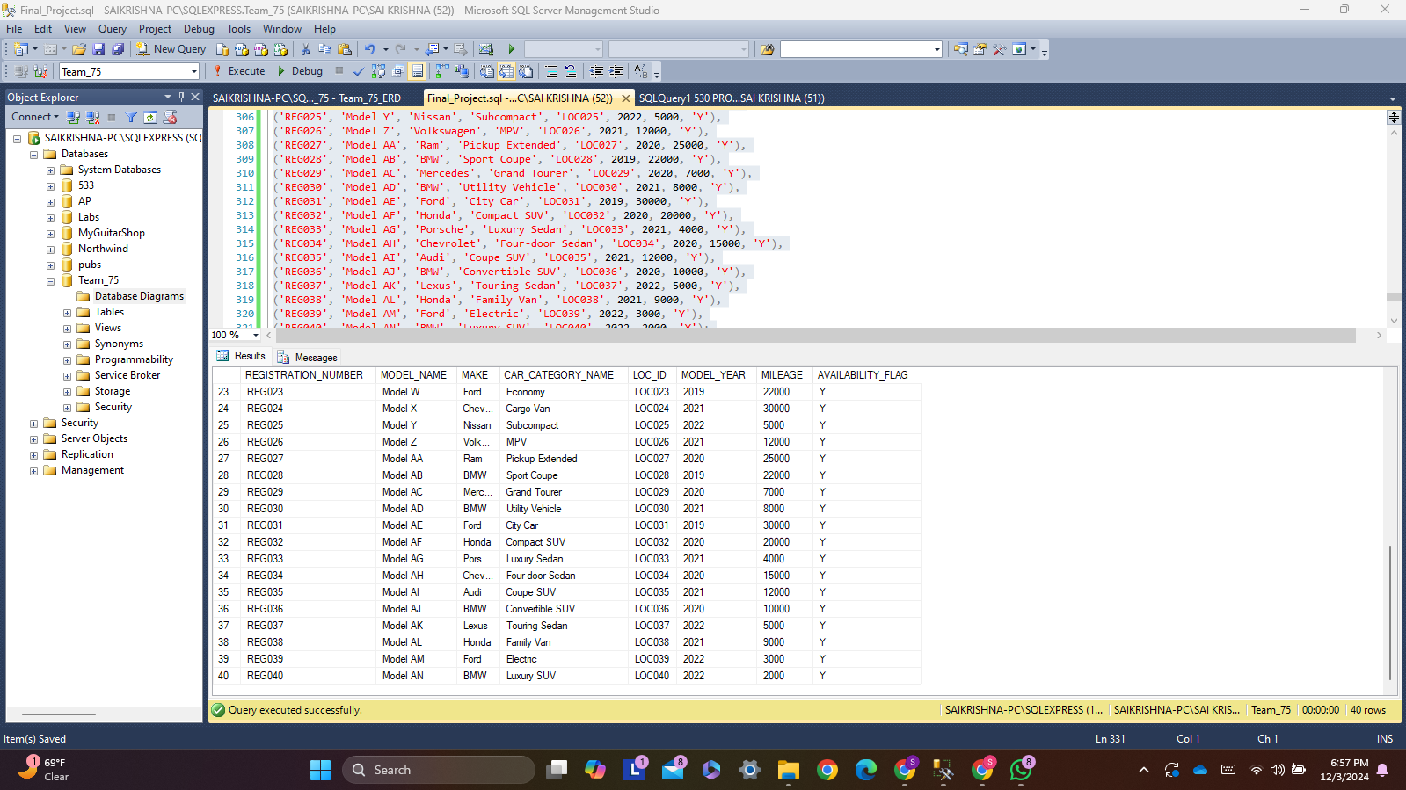

Script for Discount Table:

INSERT INTO Discount_Details

(DISCOUNT_CODE, DISCOUNT_NAME, DISCOUNT_PERCENTAGE, EXPIRY_DATE)

VALUES

('DISC01', 'New Year Discount', 10.00, '2025-01-01'),

('DISC02', 'Summer Sale', 15.00, '2025-06-30'),

('DISC03', 'Black Friday', 25.00, '2024-11-30'),

('DISC04', 'Holiday Special', 20.00, '2024-12-31'),

('DISC05', 'Spring Discount', 10.00, '2025-03-31'),

('DISC06', 'Weekend Offer', 5.00, '2024-12-07'),

('DISC07', 'VIP Member Discount', 30.00, '2025-01-01'),

('DISC08', 'Christmas Sale', 15.00, '2024-12-25'),

('DISC09', 'Early Bird Special', 12.00, '2024-09-30'),

('DISC10', 'Clearance Sale', 50.00, '2025-05-31');

SELECT*FROM Discount_Details;

Output:

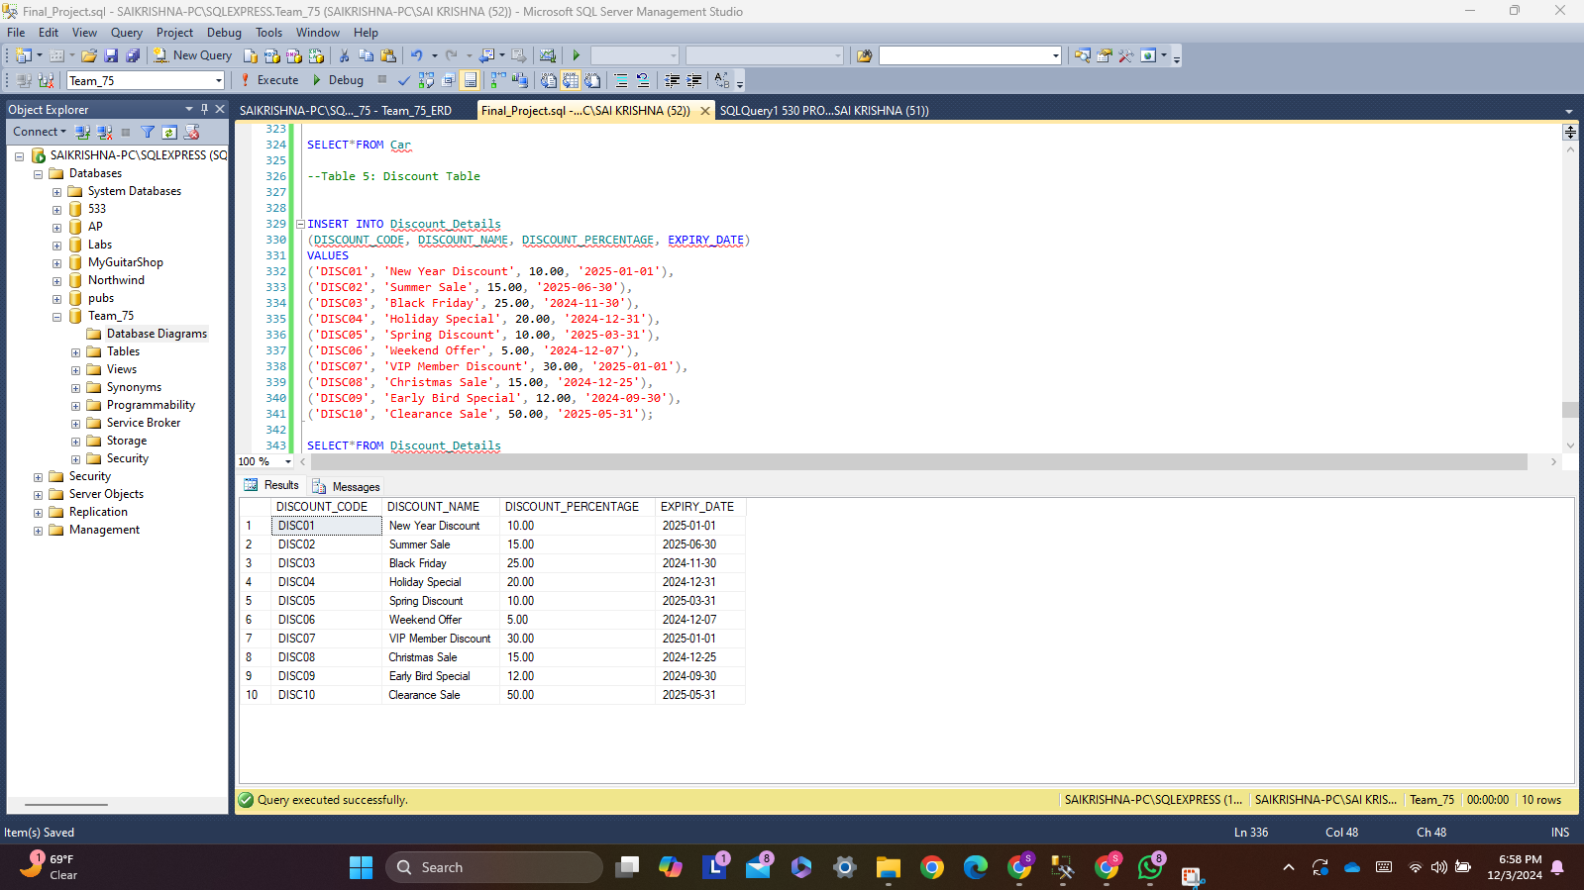

Script for Rental Car Insurance Table:

INSERT INTO Rental_Car_Insurance

(INSURANCE_CODE, INSURANCE_NAME, COST_PER_DAY, COVERAGE_TYPE)

VALUES

('INS001', 'Basic Coverage', 15.00, 'Covers damage to the car and basic liability'),

('INS002', 'Standard Coverage', 25.00, 'Covers damage to the car, basic liability, and theft protection'),

('INS003', 'Premium Coverage', 35.00, 'Covers full damage to the car, theft protection, and roadside assistance'),

('INS004', 'Roadside Assistance', 10.00, 'Provides emergency roadside assistance like flat tire change, battery jump, etc.'),

('INS005', 'Collision Damage Waiver', 18.00, 'Waives responsibility for damage to the rental car if you are at fault in an accident'),

('INS006', 'Liability Protection', 12.00, 'Provides protection against third-party claims for bodily injury or property damage'),

('INS007', 'Personal Accident Insurance', 8.00, 'Covers medical expenses for the driver and passengers in case of an accident'),

('INS008', 'Theft Protection', 20.00, 'Covers the loss of the rental car in case of theft'),

('INS009', 'Comprehensive Coverage', 45.00, 'Covers full damage, theft, roadside assistance, and loss of use'),

('INS010', 'Zero Deductible Coverage', 55.00, 'Covers all types of damage with zero deductible for the renter');

SELECT*FROM Rental_Car_Insurance;

Output:

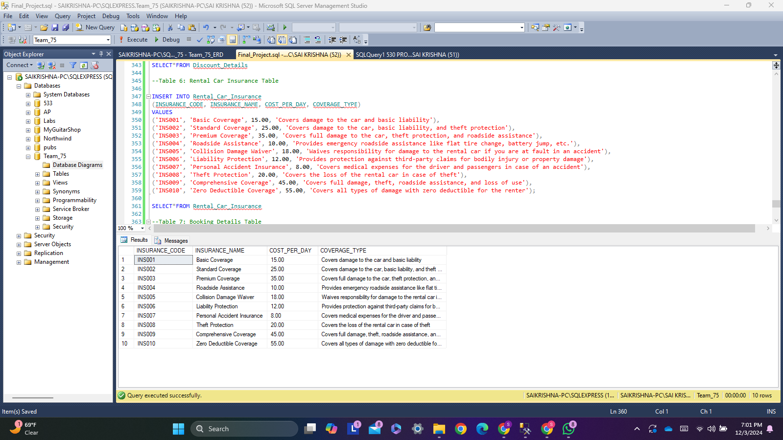

Script for Booking Details Table:

INSERT INTO Booking_Details

(BOOKING_ID, REG_NUM, DL_NUM, AMOUNT, BOOKING_STATUS, PICKUP_LOC, DROP_LOC, INS_CODE, DISCOUNT_CODE)

VALUES

('B001', 'REG001', 'D123456789', 100.00, 'A', 'LOC001', 'LOC002', 'INS001', 'DISC01'),

('B002', 'REG002', 'S987654321', 150.50, 'A', 'LOC003', 'LOC004', 'INS002', 'DISC02'),

('B003', 'REG003', 'M123456789', 200.00, 'A', 'LOC005', 'LOC006', 'INS003', 'DISC03'),

('B004', 'REG004', 'W987654321', 175.75, 'A', 'LOC002', 'LOC003', 'INS004', 'DISC04'),

('B005', 'REG005', 'B123456789', 125.50, 'A', 'LOC006', 'LOC005', 'INS005', 'DISC05'),

('B006', 'REG006', 'J987654321', 140.00, 'A', 'LOC004', 'LOC002', 'INS006', 'DISC06'),

('B007', 'REG007', 'L123456789', 220.00, 'A', 'LOC005', 'LOC004', 'INS007', 'DISC07'),

('B008', 'REG008', 'D987654321', 250.00, 'A', 'LOC001', 'LOC006', 'INS008', 'DISC08'),

('B009', 'REG009', 'M123987654', 180.25, 'A', 'LOC003', 'LOC001', 'INS009', 'DISC09'),

('B010', 'REG010', 'G987123456', 210.00, 'A', 'LOC004', 'LOC005', 'INS010', 'DISC10');

SELECT*FROM Booking_Details;

Output:

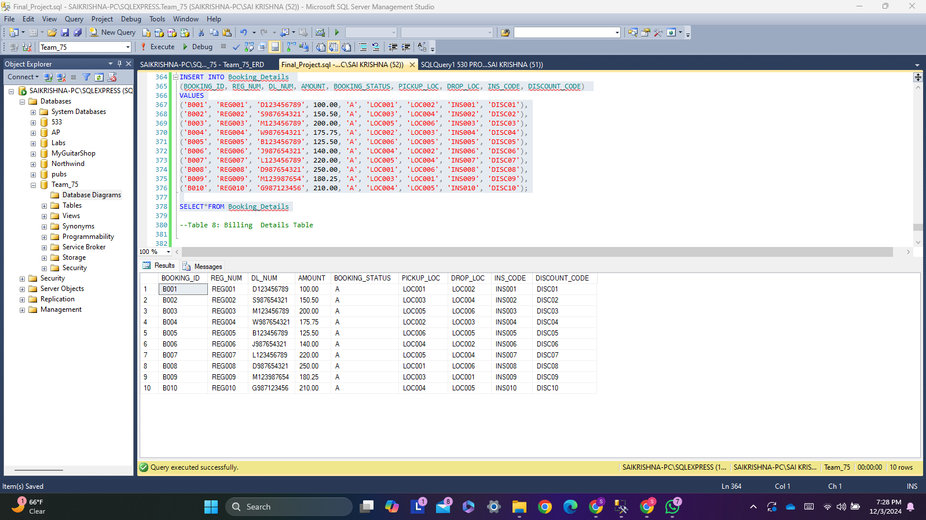

Script for Billing Details Table:

INSERT INTO Billing_Details

(BILL_ID, BILL_DATE, BILL_STATUS, DISCOUNT_AMOUNT, TOTAL_AMOUNT, TAX_AMOUNT, BOOKING_ID, TOTAL_LATE_FEE)

VALUES

('BILL01', '2024-12-01', 'P', 10.00, 100.00, 5.00, 'B001', 2.50),

('BILL02', '2024-12-02', 'P', 15.00, 150.00, 7.50, 'B002', 5.00),

('BILL03', '2024-12-03', 'C', 0.00, 200.00, 10.00, 'B003', 0.00),

('BILL04', '2024-12-04', 'P', 20.00, 175.75, 8.79, 'B004', 3.00),

('BILL05', '2024-12-05', 'C', 5.00, 125.50, 6.25, 'B005', 0.00),

('BILL06', '2024-12-06', 'P', 12.00, 140.00, 7.00, 'B006', 1.50),

('BILL07', '2024-12-07', 'P', 8.00, 220.00, 11.00, 'B007', 4.00),

('BILL08', '2024-12-08', 'C', 25.00, 250.00, 12.50, 'B008', 0.00),

('BILL09', '2024-12-09', 'P', 10.00, 180.25, 9.01, 'B009', 2.00),

('BILL10', '2024-12-10', 'P', 5.00, 210.00, 10.50, 'B010', 3.50);

SELECT*FROM Billing_Details;

Output:

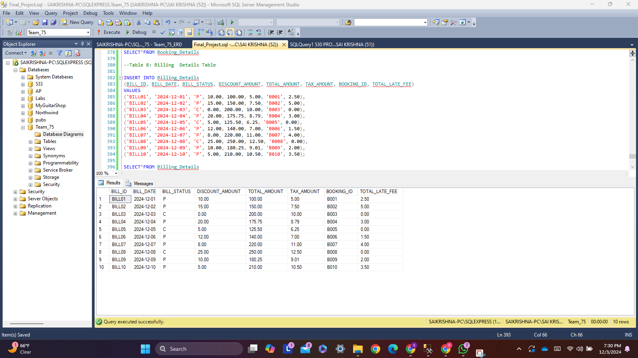

**Creating queries and converting them into views**

**Script for View 1:**

CREATE VIEW Customer_Membership_Info

AS

SELECT

CD.DL_NUMBER AS Driver_License_Number,

CD.FNAME AS First_Name,

CD.MNAME AS Middle_Name,

CD.LNAME AS Last_Name,

CD.PHONE_NUMBER AS Phone_Number,

CD.EMAIL_ID AS Email_Address,

CD.STREET AS Street_Address,

CD.CITY AS City_Name,

CD.STATE_NAME AS State_Name,

CD.ZIPCODE AS Zip_Code,

CD.MEMBERSHIP_TYPE AS Membership_Type,

CD.MEMBERSHIP_ID AS Membership_ID

FROM Customer_Details CD;

SELECT * FROM Customer_Membership_Info;

**Output:**

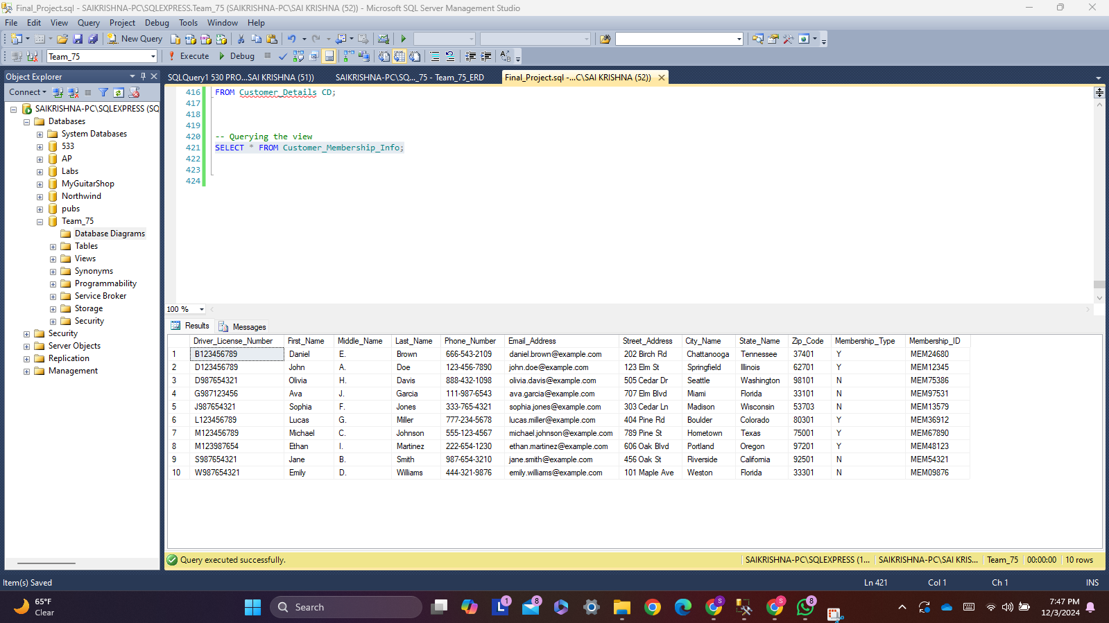

**Usage Explanation:** The "Customer_Membership_Info" view gives a complete summary of customers and their membership details. It helps the rental car agency manage customers better by showing important data like contact details, membership type, and ID. This makes customer service easier, improves marketing, and saves time by avoiding the need to check multiple tables.

**Script for View 2:**

CREATE VIEW Available_Vehicles AS

SELECT

Vehicle.REGISTRATION_NUMBER AS Vehicle_Registration_ID,

Vehicle.MODEL_NAME AS Vehicle_Model,

Vehicle.MAKE AS Vehicle_Manufacturer,

VehicleCategory.CATEGORY_NAME AS Category_Type,

VehicleCategory.NO_OF_LUGGAGE AS Luggage_Capacity,

VehicleCategory.NO_OF_PERSON AS Passenger_Capacity,

VehicleCategory.COST_PER_DAY AS Daily_Rental_Cost,

VehicleCategory.LATE_FEE_PER_HOUR AS Hourly_Late_Fee,

Vehicle.AVAILABILITY_FLAG AS Availability_Status

FROM Car AS Vehicle

JOIN Car_Category AS VehicleCategory ON Vehicle.CAR_CATEGORY_NAME = VehicleCategory.CATEGORY_NAME

WHERE VehicleCategory.NO_OF_PERSON = 4;

SELECT * FROM Available_Vehicles

**Output:**

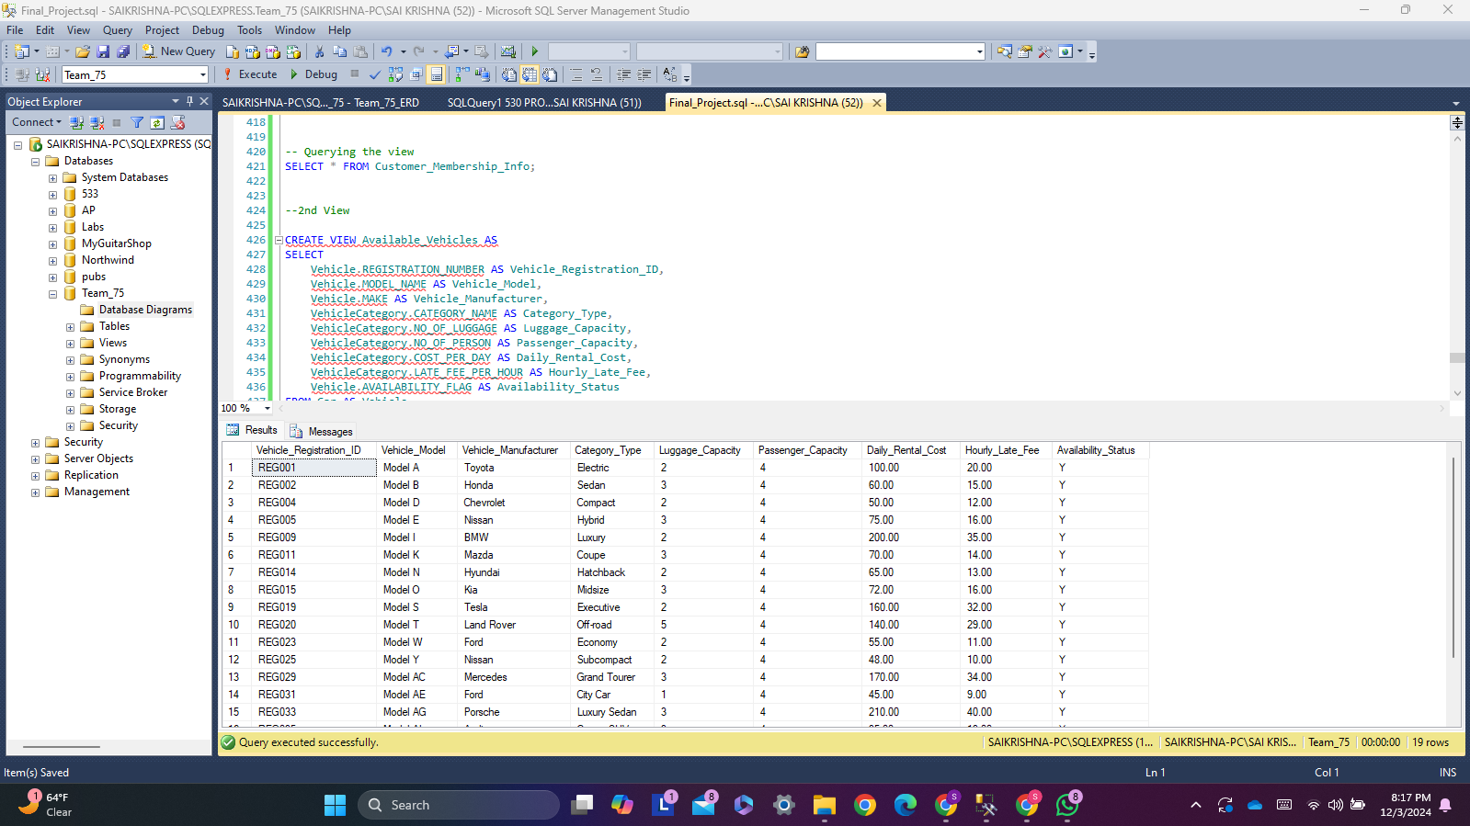

**Usage Explanation:** The "Available_Cars" view is useful for managing cars. It shows all available cars with details like model, make, luggage space, and daily rental cost. This helps the agency’s team to quickly find cars for customers. It also keeps the fleet balanced, ensuring the right cars are ready for use.

**Script for View 3:**

CREATE VIEW Active_Bookings AS

SELECT

SR.BOOKING_ID,

SR.AMOUNT,

SR.BOOKING_STATUS,

SK.BILL_ID,

SK.BILL_DATE,

SK.BILL_STATUS,

SK.DISCOUNT_AMOUNT,

SK.TOTAL_AMOUNT,

SK.TAX_AMOUNT,

SK.TOTAL_LATE_FEE

FROM Booking_Details SR

JOIN Billing_Details SK ON SR.BOOKING_ID = SK.BOOKING_ID

WHERE SK.BILL_STATUS = 'P';

select * from Active_Bookings;

**Output:**

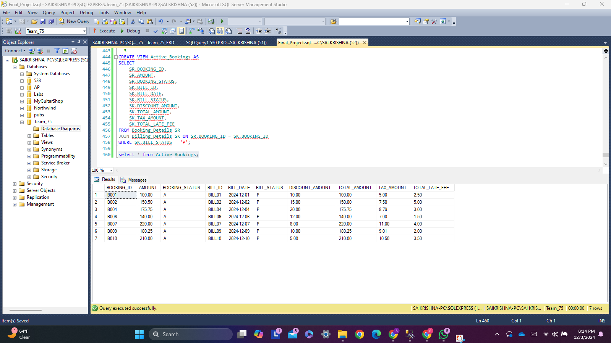

**Usage Explanation:** The "Active_Bookings" view shows important booking and billing details together. It connects booking info with billing records, making it easy to see ongoing bookings and their payment status. This helps the accounts team manage payments and keep records accurate. Customer service can also use it to answer billing or booking questions quickly, improving customer trust.

**Creating Audit Table:**

**Script for Creating Audit Table:**

CREATE TABLE Discount_Details_Audit (

AUDIT_ID INT IDENTITY(1,1) PRIMARY KEY,

ACTION_TYPE VARCHAR(15) NOT NULL,

ACTION_DATETIME DATETIME DEFAULT GETDATE(),

DISCOUNT_CODE CHAR(6) NOT NULL,

DISCOUNT_NAME VARCHAR(50) NOT NULL,

DISCOUNT_PERCENTAGE DECIMAL(5, 2) NOT NULL,

EXPIRY_DATE DATE NOT NULL

);

**Script for Insert Trigger:**

CREATE TRIGGER trg_InsertDiscount

ON Discount_Details

AFTER INSERT

AS

BEGIN

INSERT INTO Discount_Details_Audit (ACTION_TYPE, DISCOUNT_CODE, DISCOUNT_NAME, DISCOUNT_PERCENTAGE, EXPIRY_DATE)

SELECT 'INSERT', DISCOUNT_CODE, DISCOUNT_NAME, DISCOUNT_PERCENTAGE, EXPIRY_DATE

FROM INSERTED;

END;

**Script for Update Trigger:**

CREATE TRIGGER trg_UpdateDiscount

ON Discount_Details

AFTER UPDATE

AS

BEGIN

INSERT INTO Discount_Details_Audit (ACTION_TYPE, DISCOUNT_CODE, DISCOUNT_NAME, DISCOUNT_PERCENTAGE, EXPIRY_DATE)

SELECT 'UPDATE', DISCOUNT_CODE, DISCOUNT_NAME, DISCOUNT_PERCENTAGE, EXPIRY_DATE

FROM INSERTED;

END;

**Script for delete Trigger:**

CREATE TRIGGER trg_DeleteDiscount

ON Discount_Details

AFTER DELETE

AS

BEGIN

INSERT INTO Discount_Details_Audit (ACTION_TYPE, DISCOUNT_CODE, DISCOUNT_NAME, DISCOUNT_PERCENTAGE, EXPIRY_DATE)

SELECT 'DELETE', DISCOUNT_CODE, DISCOUNT_NAME, DISCOUNT_PERCENTAGE, EXPIRY_DATE

FROM DELETED;

END;

**Testing the Audit Results:**

**Script for Insert:**

INSERT INTO Discount_Details (DISCOUNT_CODE, DISCOUNT_NAME, DISCOUNT_PERCENTAGE, EXPIRY_DATE)

VALUES ('DISC1', 'New Year New Ofers', 10.00, '2024-12-31');

SELECT*FROM Discount_Details

**Output:**

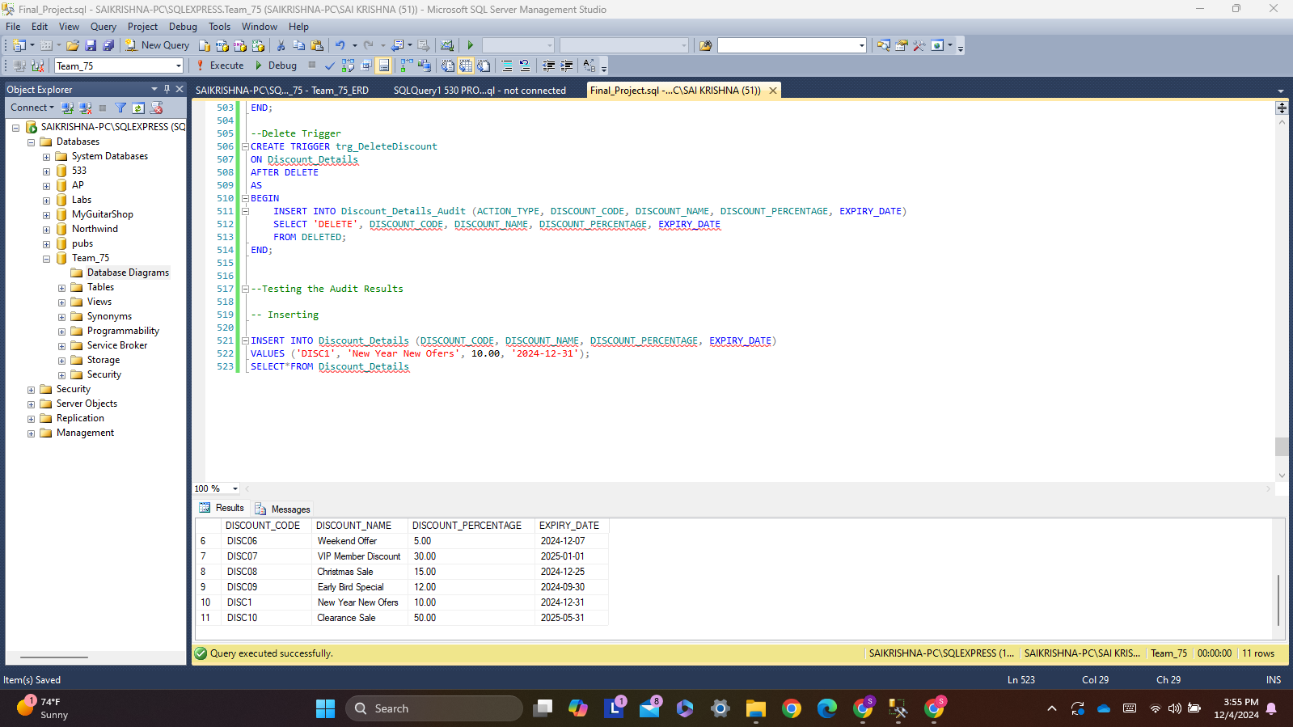

**Script for Update:**

UPDATE Discount_Details

SET DISCOUNT_PERCENTAGE = 33.00

WHERE DISCOUNT_CODE = 'DISC1';

SELECT*FROM Discount_Details

**Output:**

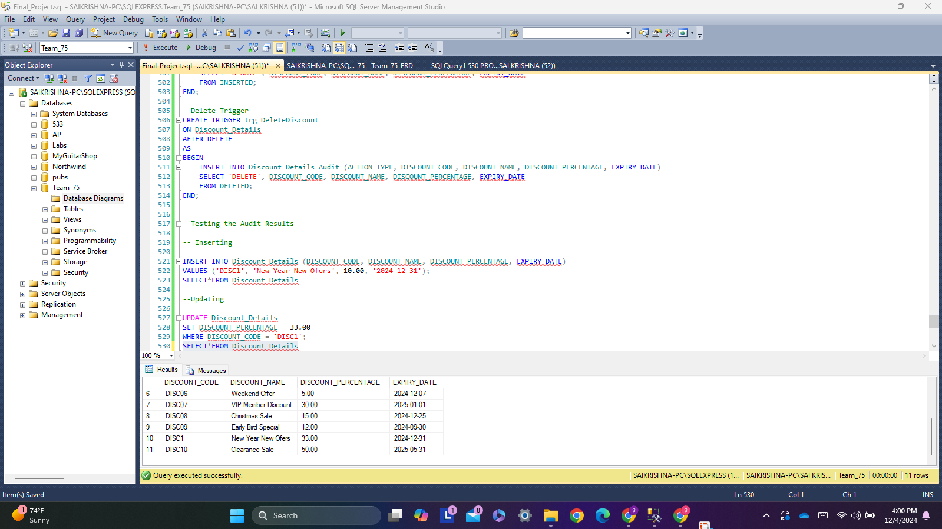

**Script for Delete:**

DELETE FROM Discount_Details

WHERE DISCOUNT_CODE = 'DISC1';

SELECT*FROM Discount_Details

**Output:**

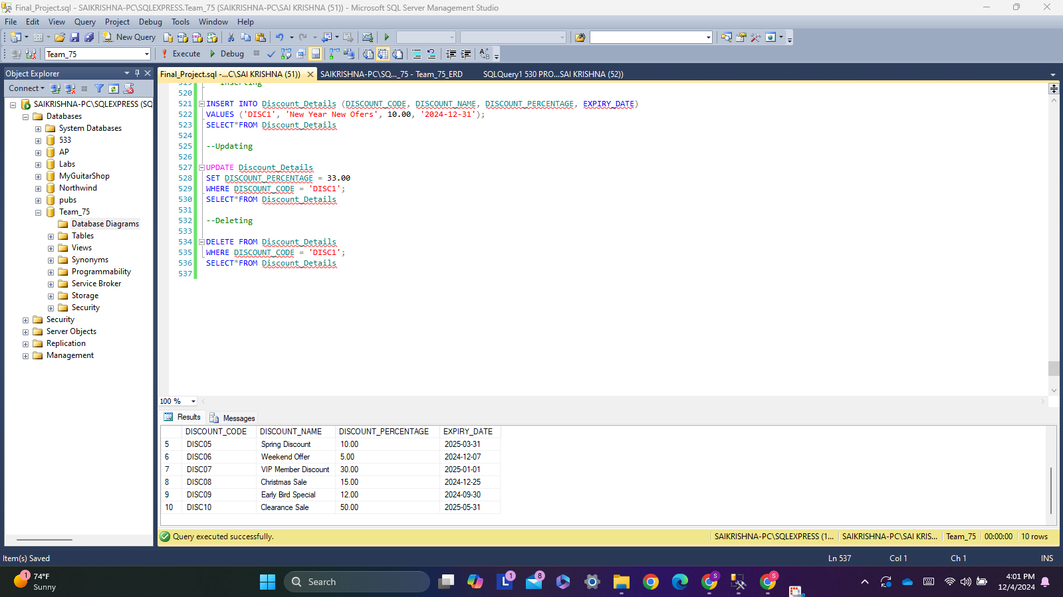

**Script To show Discount_Details_Audit table:**

SELECT * FROM Discount_Details_Audit;

**Output:**

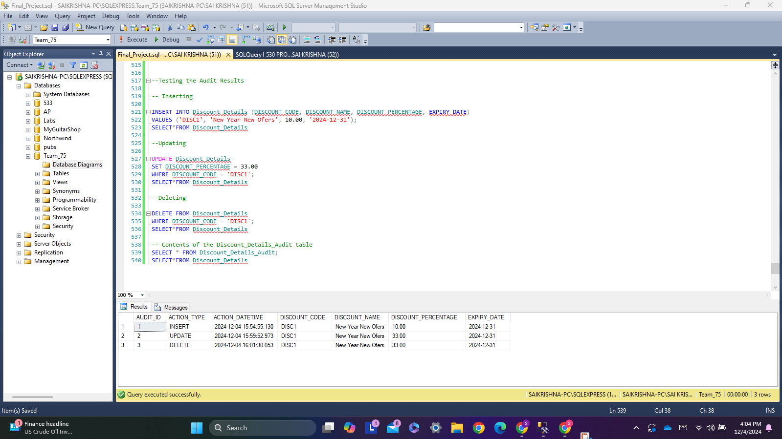

**Summary and Usage:**

The Discount_Details_Audit table keeps track of changes made to the original Discount_Details table, such as when data is inserted, updated, or deleted. This can be done using triggers in SQL Server. This setup makes sure that every change in the Discount_Details table is recorded in the Discount_Details_Audit table, creating a complete history of all actions.

**Stored Procedure and User Defined Function**

**Script for Stored Procedure:**

CREATE PROCEDURE GetAvailableCars

@CategoryName VARCHAR(30),

@LocationID CHAR(6)

AS

BEGIN

SELECT

REGISTRATION_NUMBER,

MODEL_NAME,

MAKE,

CAR_CATEGORY_NAME,

LOC_ID,

MODEL_YEAR,

MILEAGE

FROM

Car

WHERE

CAR_CATEGORY_NAME = @CategoryName

AND LOC_ID = @LocationID

AND AVAILABILITY_FLAG = 'Y';

END;

**Execution:**

EXEC GetAvailableCars @CategoryName = 'SUV', @LocationID = 'LOC003';

**Output:**

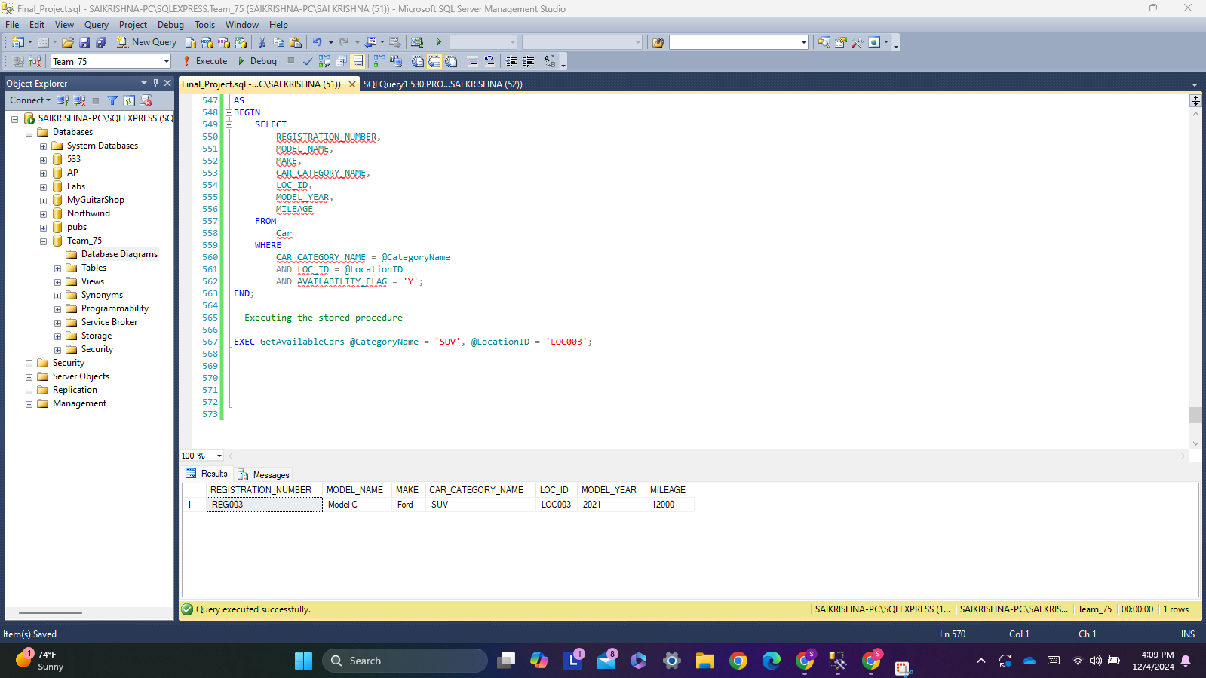

**Dropping:**

DROP PROCEDURE GetAvailableCars;

The location and a car category are used by this stored function to retrieve available cars.

**Script for User Defined Function:**

CREATE FUNCTION CalculateRentalCost

(

@CostPerDay DECIMAL(7, 2),

@LateFeePerHour DECIMAL(6, 2),

@RentalDays INT,

@LateHours INT

)

RETURNS DECIMAL(10, 2)

AS

BEGIN

RETURN (@CostPerDay * @RentalDays) + (@LateFeePerHour * @LateHours);

END;

**Execution:**

SELECT dbo.CalculateRentalCost(60.00, 15.00, 5, 3) AS TotalCost;

**Output:**

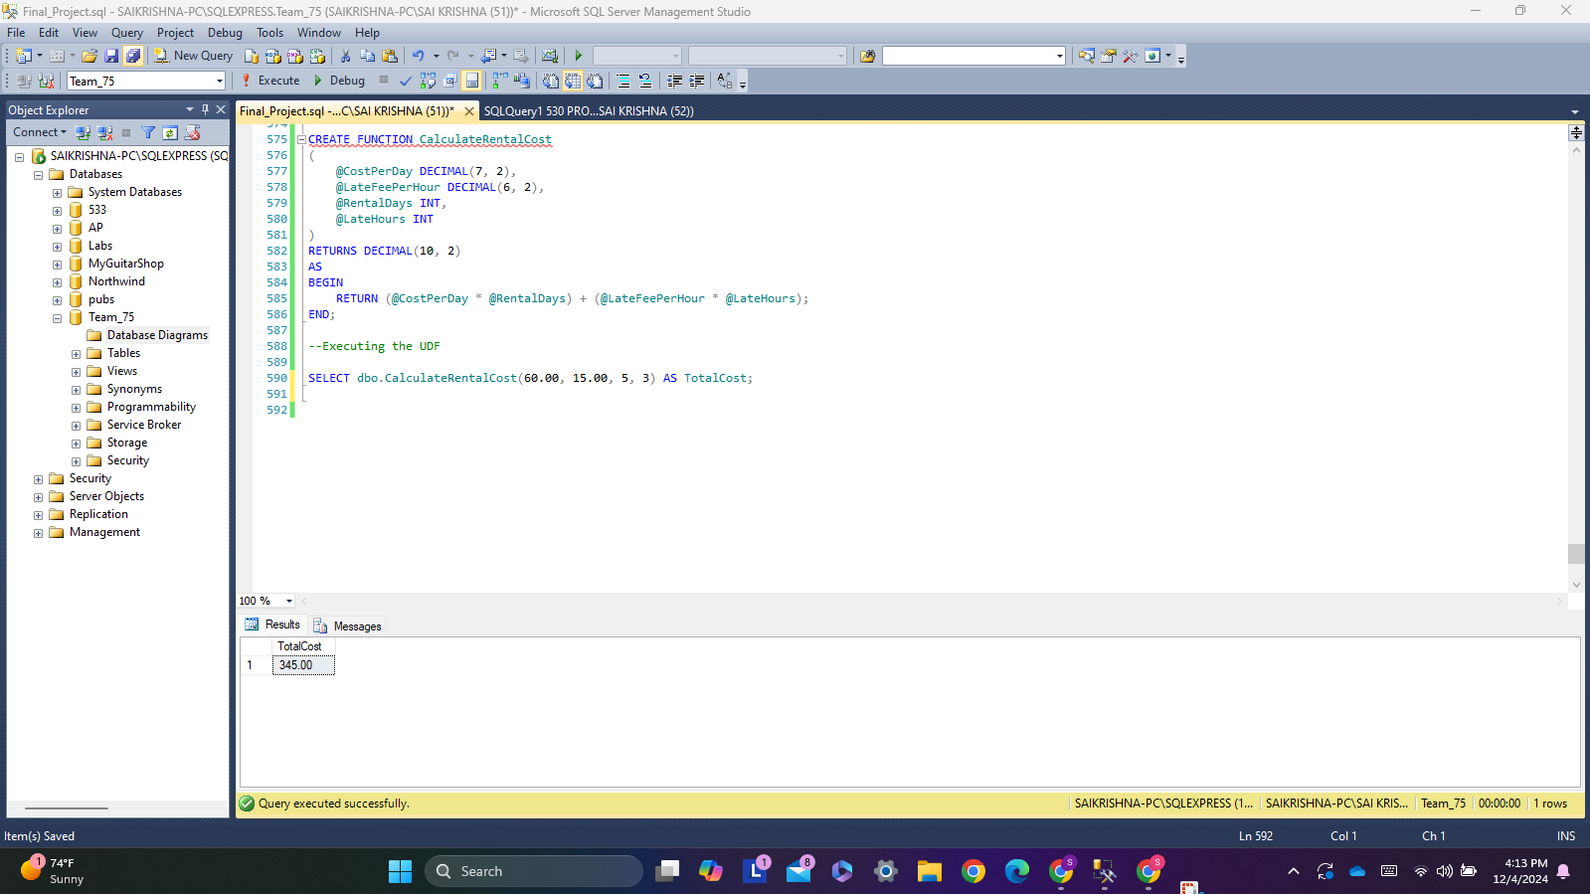

**Dropping:**

DROP FUNCTION CalculateRentalCost;

Based on the amount of rental days and late hours, this function determines the entire cost of a car rental, including late fees.

**Cursor**

**Script For Cursor Creation:**

-- Cursor

CREATE PROCEDURE MarkUnavailableCars

AS

BEGIN

-- Declare the cursor

DECLARE CarCursor CURSOR FOR

SELECT REGISTRATION_NUMBER, MILEAGE

FROM Car

WHERE MILEAGE > 100;

-- Declare variables to hold values from the cursor

DECLARE @RegistrationNumber CHAR(10);

DECLARE @Mileage INT;

-- Open the cursor

OPEN CarCursor;

-- Fetch the first row

FETCH NEXT FROM CarCursor INTO @RegistrationNumber, @Mileage;

-- Loop through all rows

WHILE @@FETCH_STATUS = 0

BEGIN

-- Print a message about the car

PRINT 'Car with Registration Number ' + @RegistrationNumber +

' and Mileage ' + CAST(@Mileage AS VARCHAR) +

' exceeds 100 miles and should be marked unavailable.';

-- Fetch the next row

FETCH NEXT FROM CarCursor INTO @RegistrationNumber, @Mileage;

END;

**Output:** 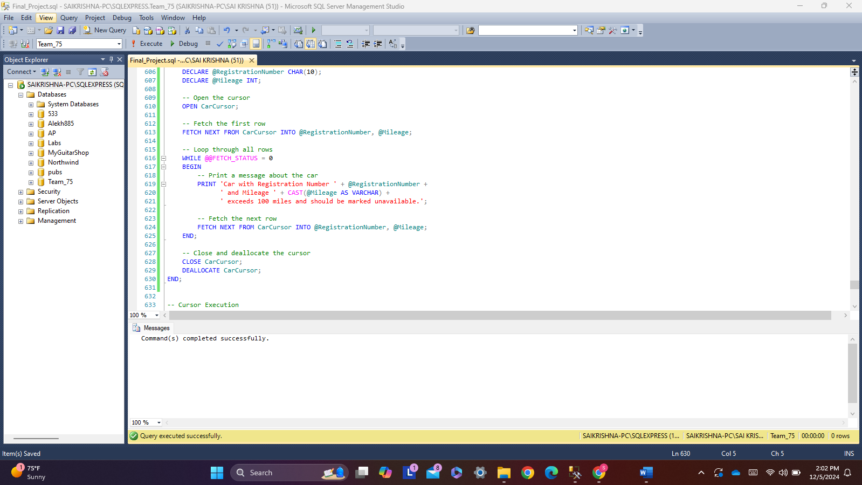

**Script for Closing and Deallocating Cursor:**

-- Close and deallocate the cursor

CLOSE CarCursor;

DEALLOCATE CarCursor;

**Output:**

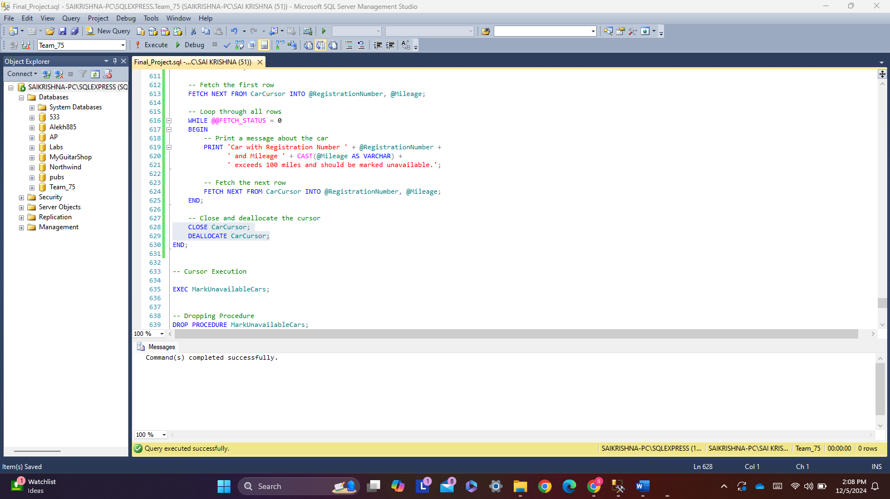

**Script for Cursor Execution:**

-- Cursor Execution

EXEC MarkUnavailableCars;

**Output:**

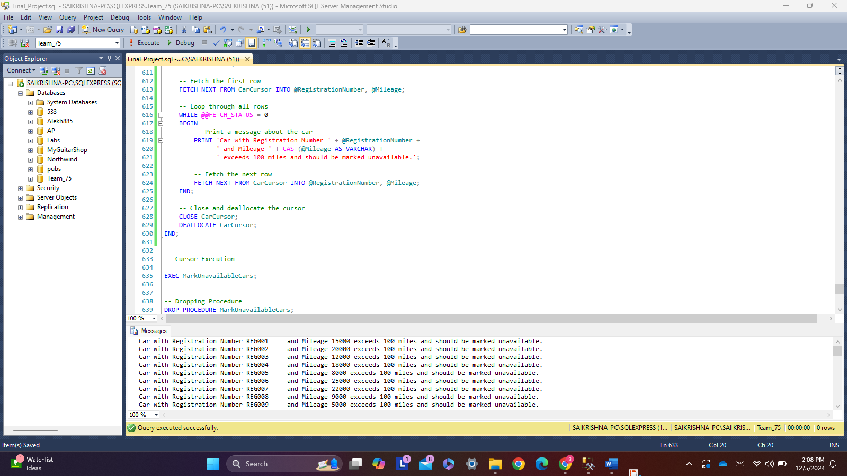

**Dropping Procedure:**

-- Dropping Procedure

DROP PROCEDURE MarkUnavailableCars;

**Output:**

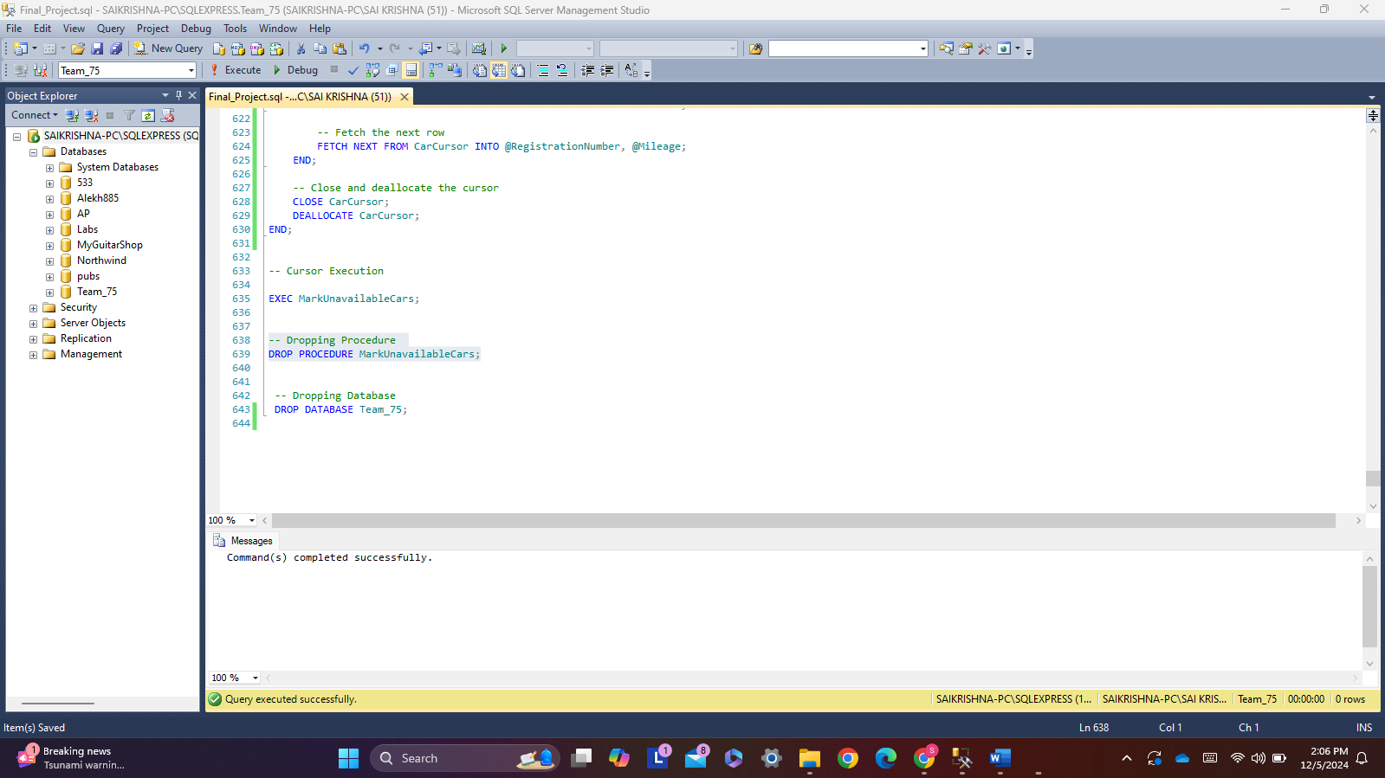

In this example, a list of cars is iterated through, and if their mileage surpasses a predetermined level, they are marked as unavailable.

**Explanation of Cursor Usage:**

**Declaration of Cursor:**

A SELECT query that gets vehicles with more mileage than the threshold (100000 in this case) is used to declare the cursor.

**Cursor Functions:**

OPEN CarCursor: To begin reading rows, open the cursor.

FETCH NEXT FROM CarCursor INTO: This function assigns the following row to the variables after retrieving it from the result set.

The loop continues until every row has been handled. WHILE @@FETCH_STATUS = 0.

When the cursor is not anymore required, resources are freed by CLOSE and DEALLOCATE CarCursor.

**Operation Update:**

The UPDATE statement indicates that the automobile is unavailable for every row that is fetched.